**ITIS 5250-091 Computer Forensics**

**Graduate Lab Project**

***Name: Divyansh Jain***

***ID: 801364884***

***Date: 11/30/2023***

**Overview:**

Detective Rey Mysterio hands over John Cena's laptop, the prime suspect in the murder at Maple Street—a shocking crime that has rattled the city. As a digital forensic investigator, I decipher Cena's encrypted files, unveiling a methodical plan. His web history, communication logs, and concealed files expose a disturbing level of premeditation and collaboration within the group, showcasing diverse technical abilities that may involve anti-forensic tactics. The EnCase E01 format image of Cena's desktop is ready for scrutiny, emphasizing the group's reliance on technology, with the absence of additional evidence at the scene underscoring their adept use of digital methods. I compile a comprehensive report for Detective Mysterio, revealing Cena's digital trail and presenting crucial evidence for a swift resolution in The Rock's murder case at Maple Street.

**Tools Used:**

1. Access data PRTK v8.2.1.971
2. Arsenal image mounter 3.6.188.0
3. Autopsy v4.21.0
4. FTK Imager 4.7.1.2
5. Snipping Tool
6. Access Data Registry Viewer v1.7.4.2
7. Registry explorer v1.1.0.6

**Device Used:**

Windows Laptop:

* + Installed RAM 16.0 GB
  + Device ID A01F6F98-11AD-4E14-9EF2-D67758FF410F
  + Product ID 00342-20963-56750-AAOEM
  + System type 64-bit operating system, x64-based processor
  + Edition Windows 11 Home
  + Version 22H2

**Preparations for the task:**

* Initially, I installed investigation tools, including Access Data PRTK, Access Data Registry Viewer, and Registry Explorer.
* Subsequently, the John2020.E01 file was mounted onto Arsenal Image Mounter, and the hash of the John2020.E01 image file was authenticated using FTK Imager.

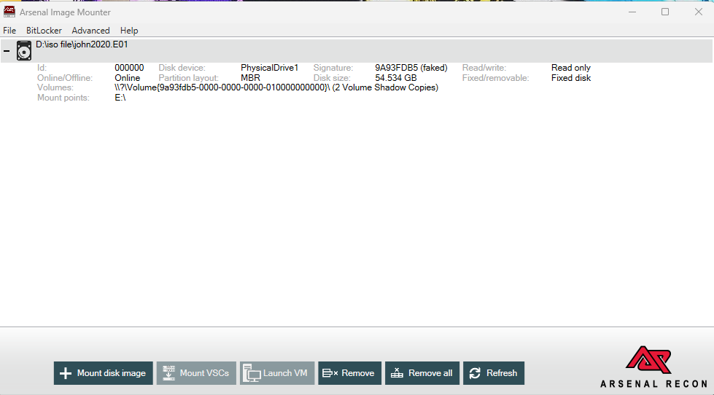

***Fig 1: Mounting John2020.E01***

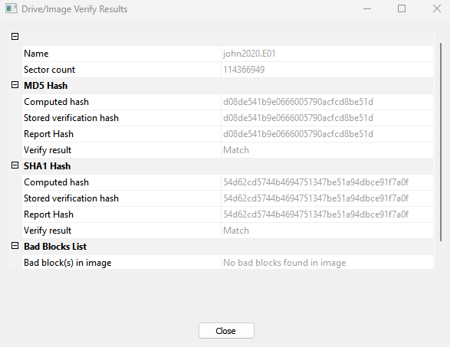

***Fig 2: Hash verification of john2020.E01***

**Findings:**

1. Can you verify whether the laptop recovered from the suspect belongs to him?

In the OS accounts, the username "john" has been identified. Additionally, in the path WINDOWS >> SYSTEM32 >> CONFIG >> SOFTWARE, the file was extracted and opened in Registry Explorer. Within the Registry Explorer, navigating to windows NT >> current version revealed that the Registered Owner is [john.cena38@outlook.com](mailto:john.cena38@outlook.com" \t "_new), and the Registered Organization is JohncenaCorp.

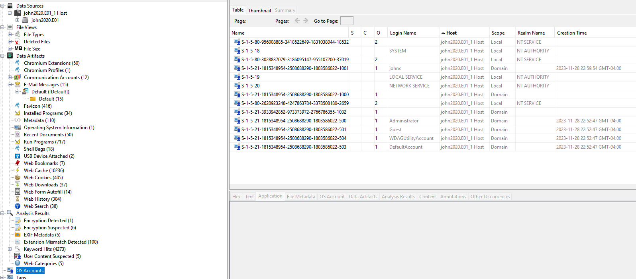

***Fig 3: OS Accounts***

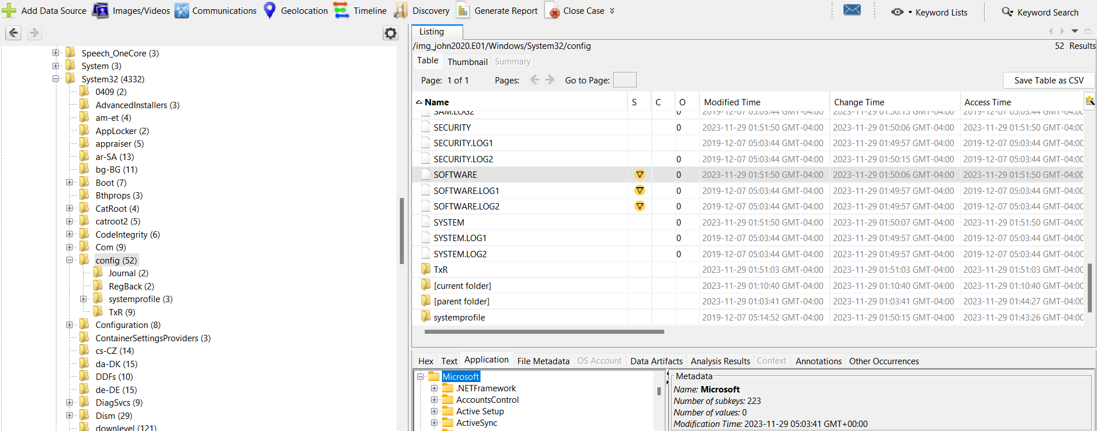

***Fig 4: Software file***

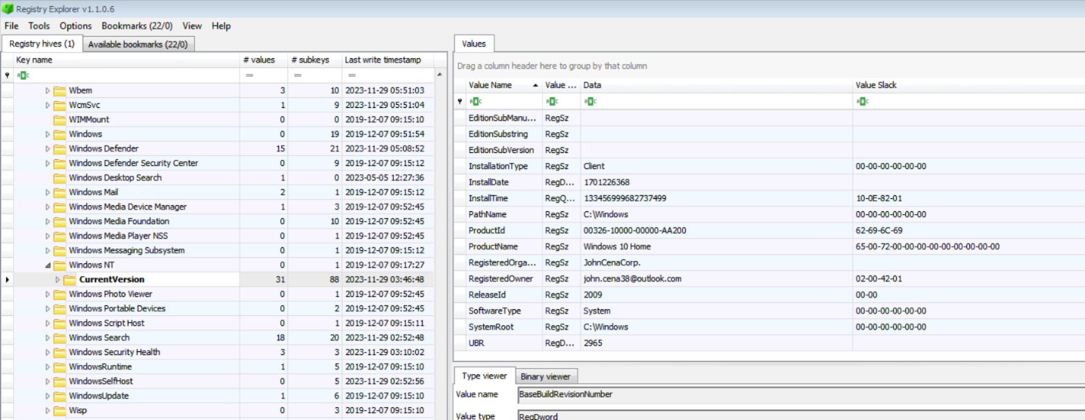

***Fig 5: Organization and owner name***

1. Has John Cena taken anything from the residence? Additionally, are there any specific items reported missing or any signs of theft?

Detective Rey Mysterio noted the presence of a mark on Rock's finger resembling that of a ring, which appears to be absent as no ring was discovered during the crime scene examination. Upon analyzing the john2020.E01 file, a photograph of a diamond ring was located in the directory Users >> johnc >> Onedrive >> pictures, labeled as "rock’s ring."

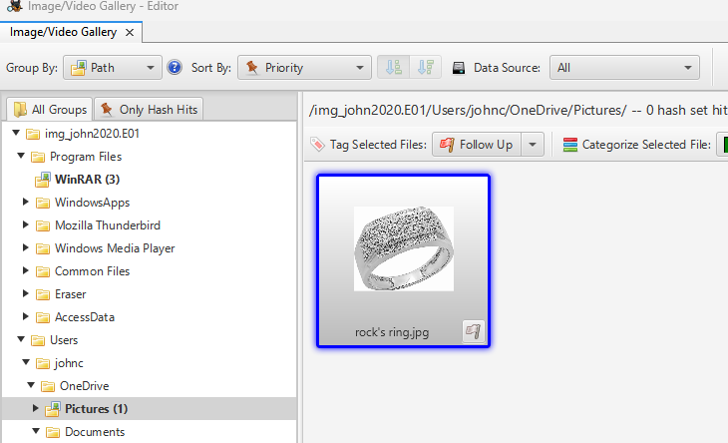

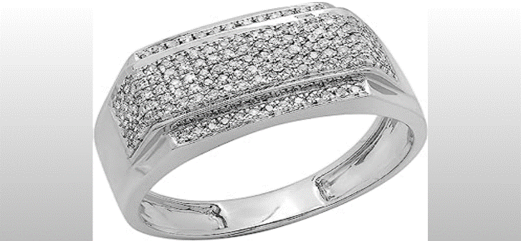

***Fig 6: Rock’s diamond ring***

1. Are there any other individuals associated with the suspect John Cena whom you believe might have assisted him in committing the murder?

Within the data artifacts under E-Mail Messages >> Default, it was discovered that owner of the machine had been in communication with an individual, whose email address is under.taker78@outlook.com. In the correspondence, user requested under.taker78@outlook.com to pick him up from a location near the crime scene identified as Park Street around 10:00 p.m., just 30 minutes after the time of the murder. This information strongly suggests the potential involvement of [under.taker78@outlook.com](mailto:under.taker78@outlook.com) in the murder case of Rock.

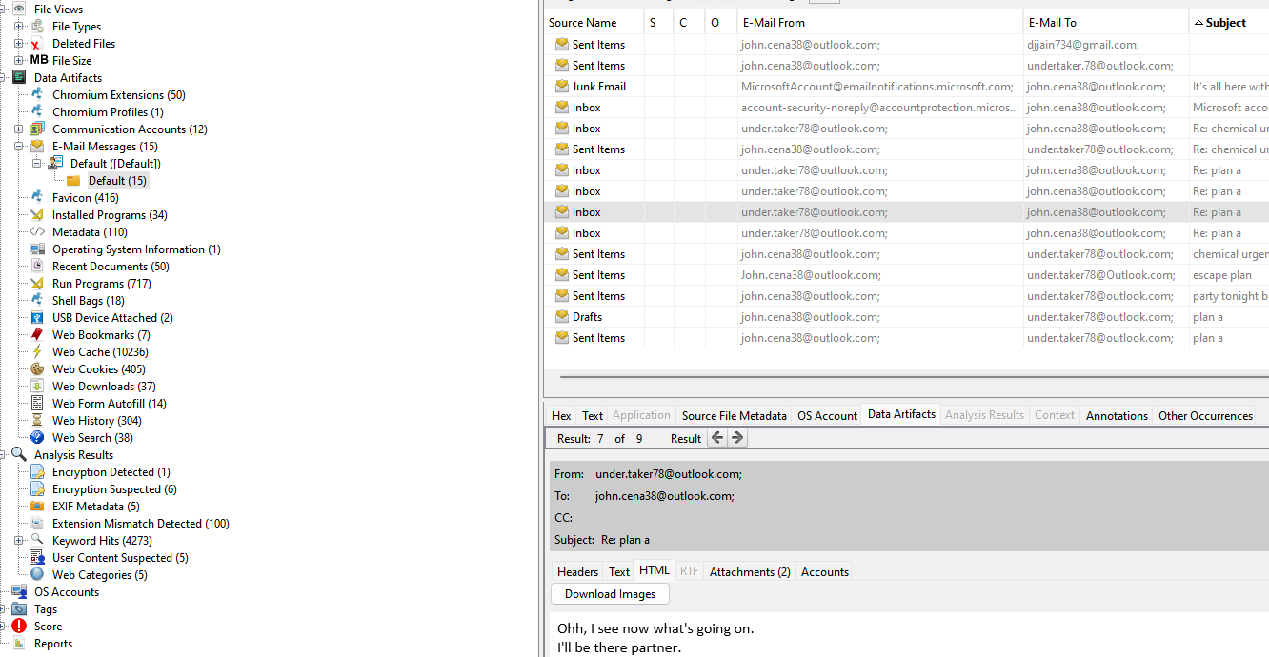

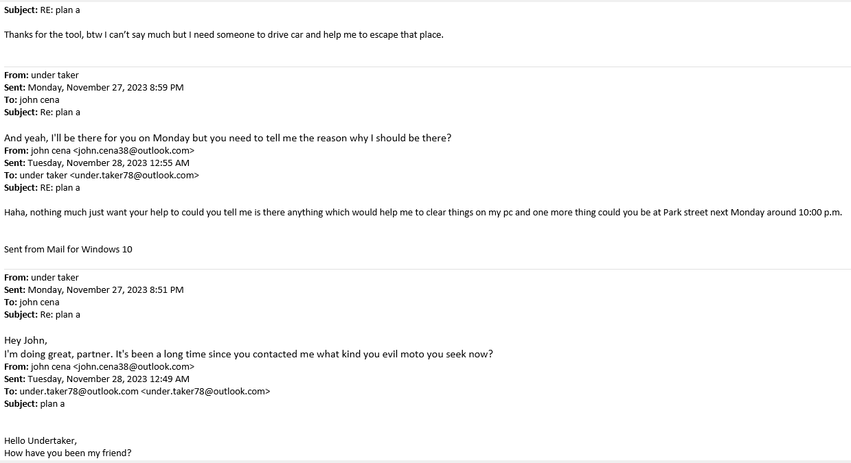

***Fig 7: Correspondence Emails with Undertaker***

1. Are there any visuals depicting the tools or weapons potentially employed in the act of murder?

Images of a rope, fingerprint cleaner, and fingerprint-proof gloves were discovered in the directory Users >> johnc >> Onedrive >> pictures >> weaponstools. Upon a more in-depth analysis of the web history, links to Amazon for these tools were identified, indicating that this items are likely purchased from the Amazon platform.

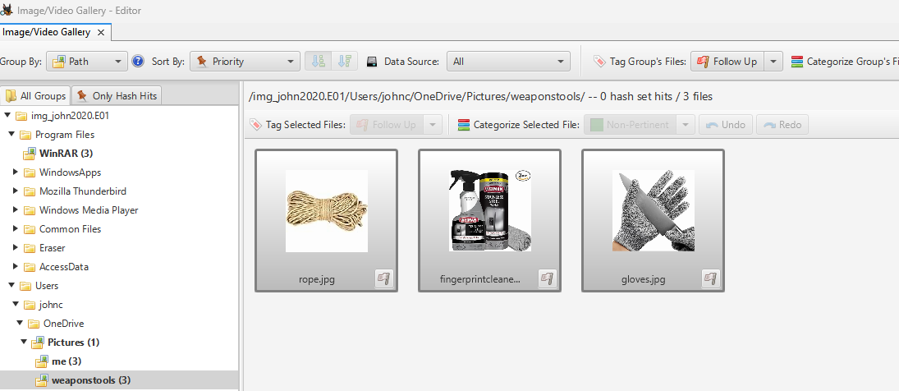

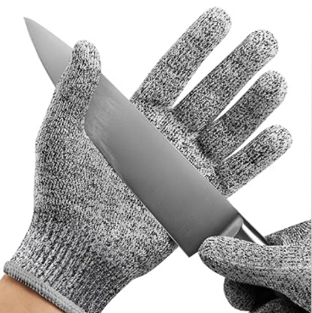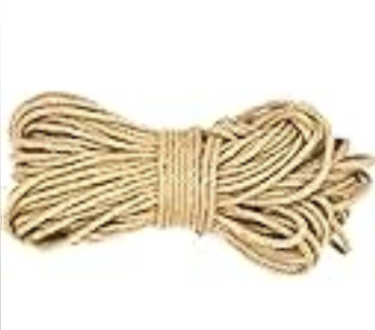

***Fig 8: Tools found***

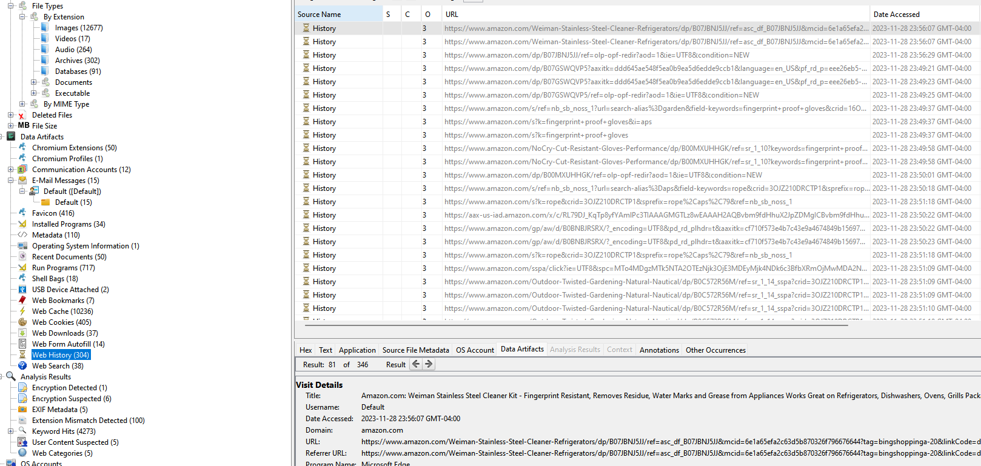

***Fig 9: Web history***

1. Which social media platform or software did John utilize to communicate with the Undertaker, and what is the usage count of that program?

Upon examining the Installed Programs within the data artifacts, it was determined that machine owner had installed the Thunderbird program, which appears to be utilized for communication with other suspects. Further analysis of the Run Programs revealed that Thunderbird had been run a total of 28 times.

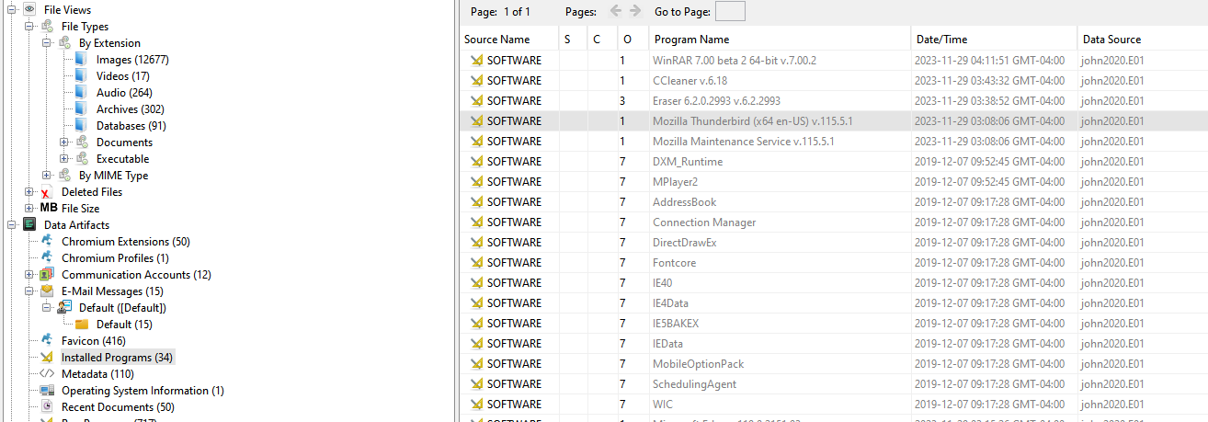

***Fig 9: Installed Programs***

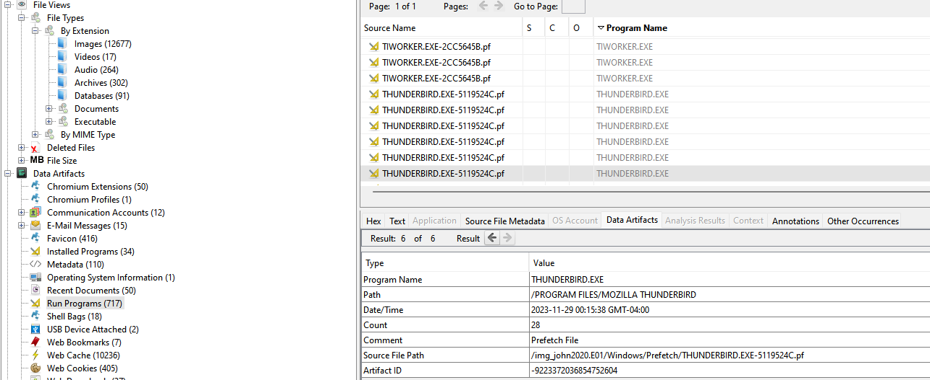

***Fig 10: Run count of Thunderbird***

1. From the CCTV footage obtained by Detective Rey Mysterio from the parking lot camera, a white car was observed leaving the crime scene approximately 20 minutes after the murder occurred. Can you identify the model of this vehicle?

Within the Analysis results >> Encryption section, a Zip file titled "theescape.zip" was identified. After extracting and utilizing the PRTK tool to crack the password of the zip file, images of a white car were revealed, identified as a "Toyota Corolla SE CVT."

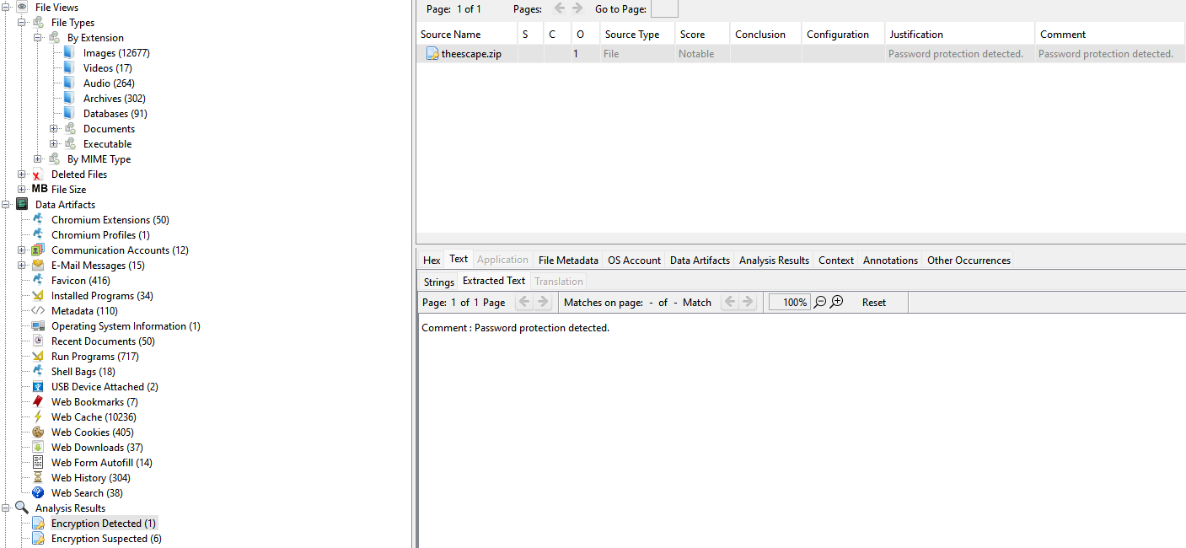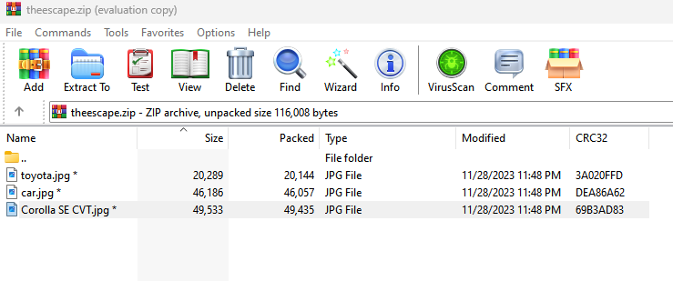

***Fig 11: theecape.zip File***

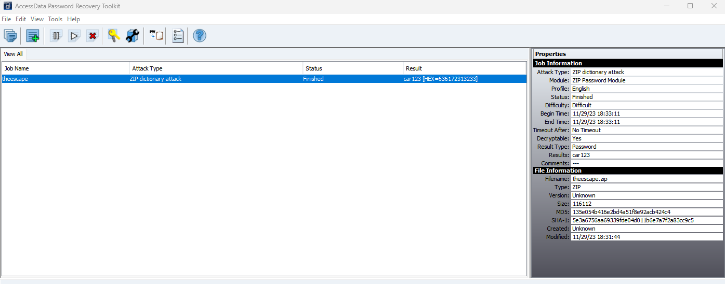

***Fig 12: Password of zip file***

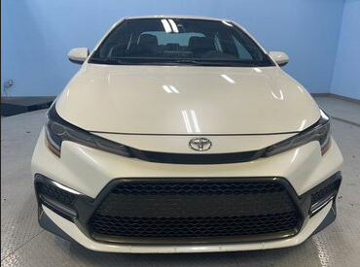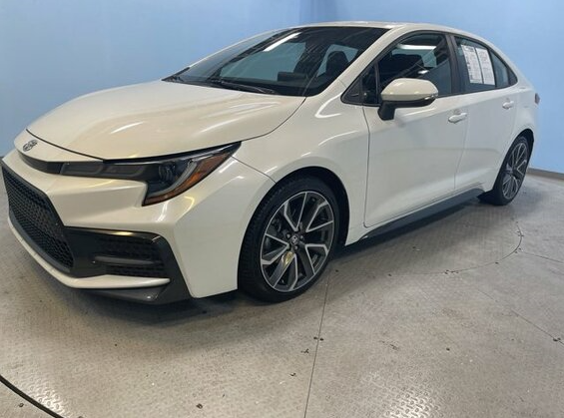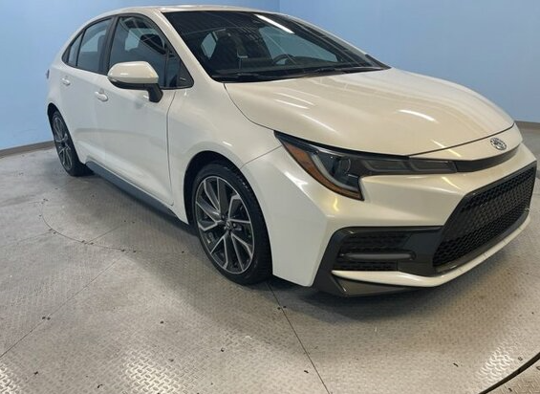

***Fig 13: White car***

1. Do you possess a photograph or visual representation that provides a depiction of what John Cena looks like?

Photographs of an individual were unearthed in the directory Users >> johnc >> Onedrive >> pictures >> me, with the label "John." These images provide a visual representation of John's appearance.

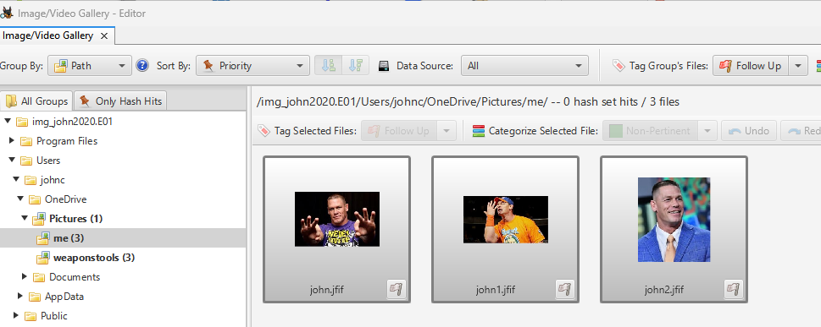



***Fig 14: John’s Pictures***

1. Which tools did John employ to eradicate digital traces, and what is the count of these tools? Unraveling this aspect is crucial for understanding the extent of his efforts to cover his tracks and evade detection.

In the examination of emails, it was revealed that owner of machine had inquired with under.taker78@outlook.com about tools to clear up information on his computer. Further investigation into installed programs within the data artifacts uncovered that owner of machine had installed CCleaner and Eraser, indicating their potential use for erasing digital evidence. A detailed analysis of executed programs disclosed that Eraser had been utilized five times, while CCleaner had been run on ten occasions. Additionally, within the File types >> By Extension >> Documents >> PDF category, documentation for Eraser was found, suggesting that John was actively learning to employ these anti-forensic tools.

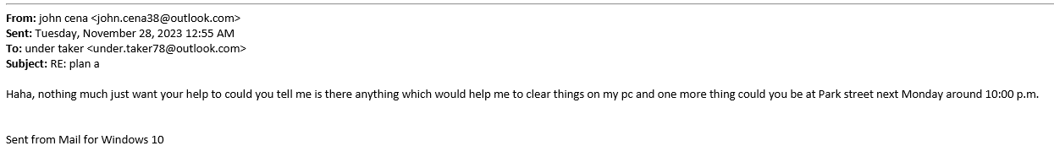

***Fig 15: Email of inquiry about tool***



***Fig 16: Installed Programs***

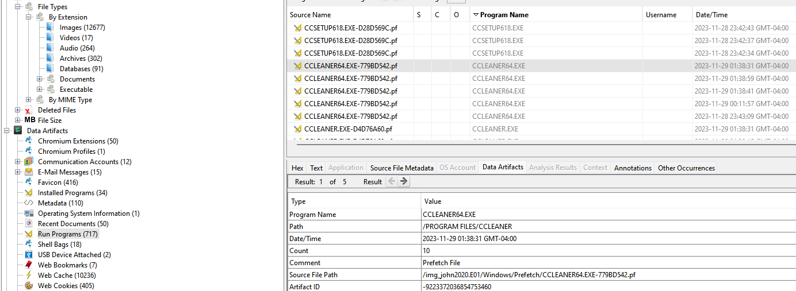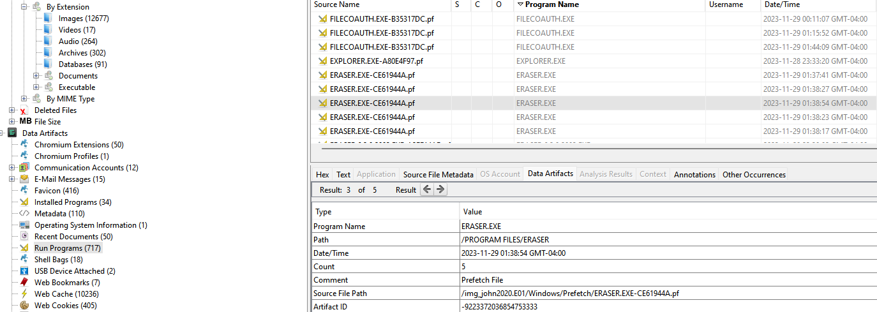

***Fig 17: Run count of CCleaner and Eraser***

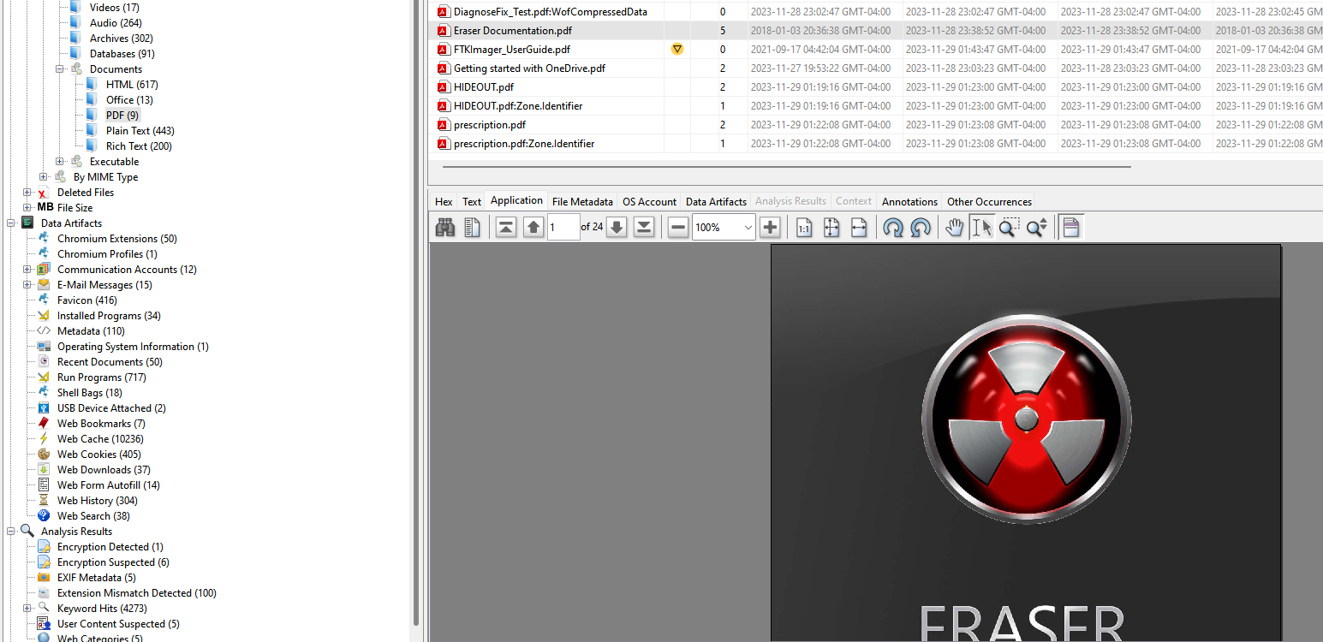

***Fig 18: Eraser documentation***

1. Are there any compelling pieces of evidence that could lead us to the hideout, providing crucial information for further investigation?

Upon extraction and analysis, the file contained directions outlining a route from Maple Street to 419 Barton Creek Dr., indicating a potential location for the hideout. Interestingly, the same file was also detected in the Cache data.

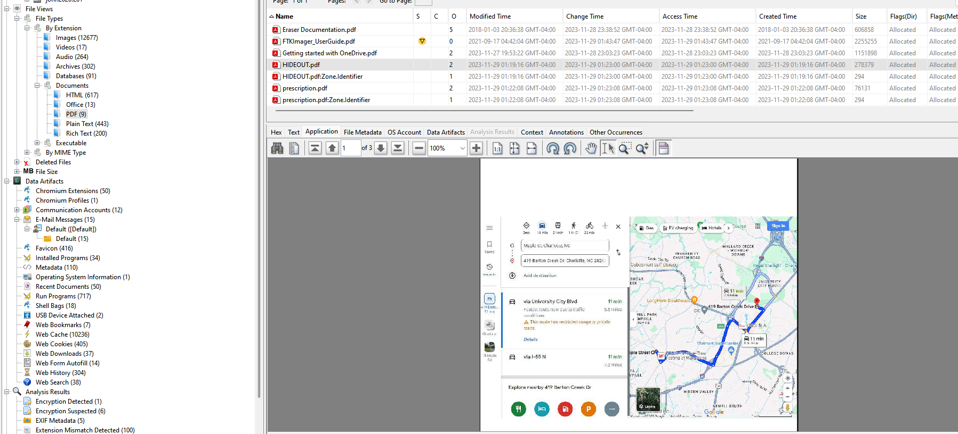

***Fig 19: Hideout.pdf file***

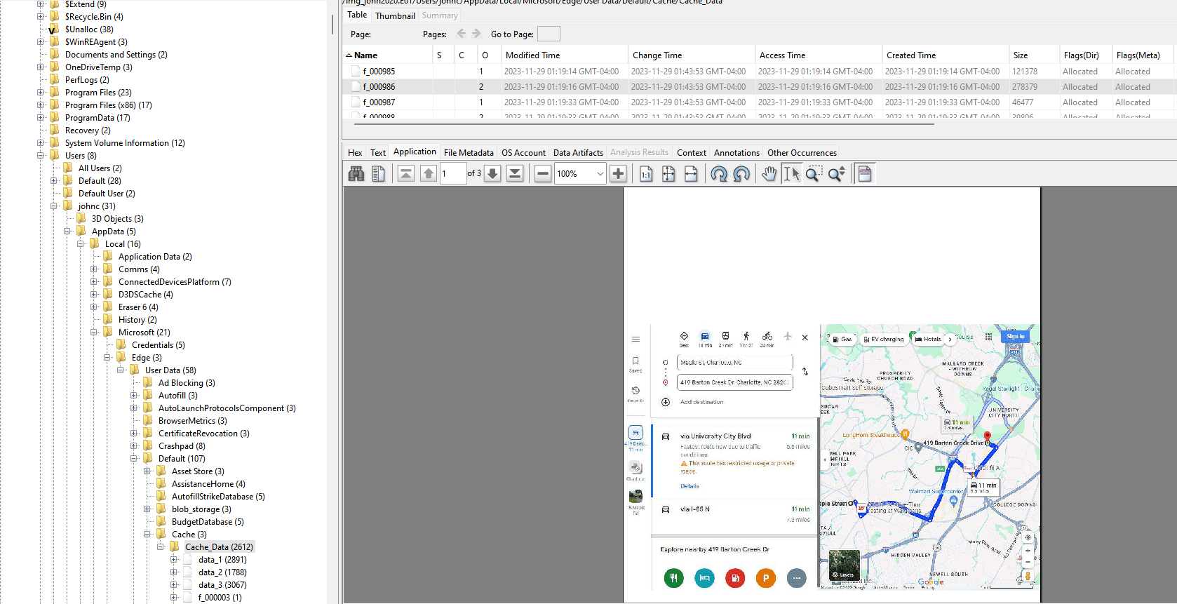

***Fig 20: Route to hideout in Cache data***

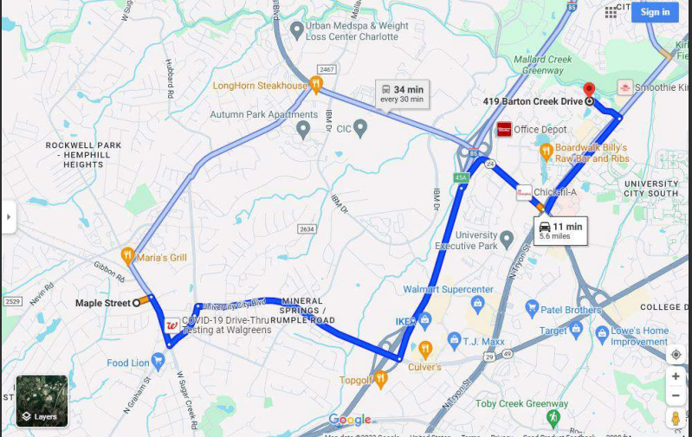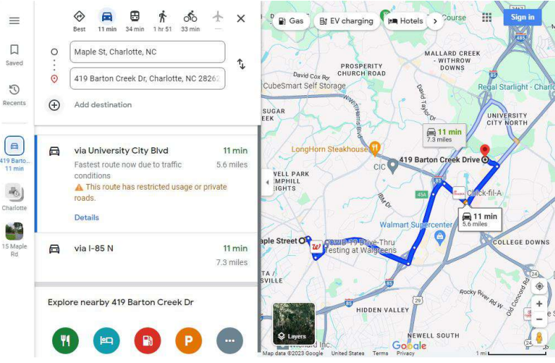

***Fig 21: Hideout location***

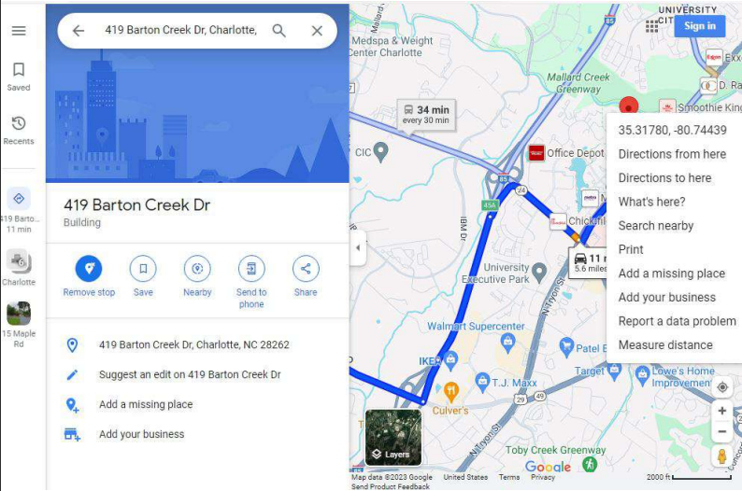

***Fig 22: Coordinates of the hideout***

1. How many USB devices have been connected to John's system? Additionally, can we identify any external devices that have been plugged into his system?

In the Data artifacts >> USB Device Attached section, it was determined that two devices were connected to machine, identified as ROOT\_HUB30 and USB Tablet.

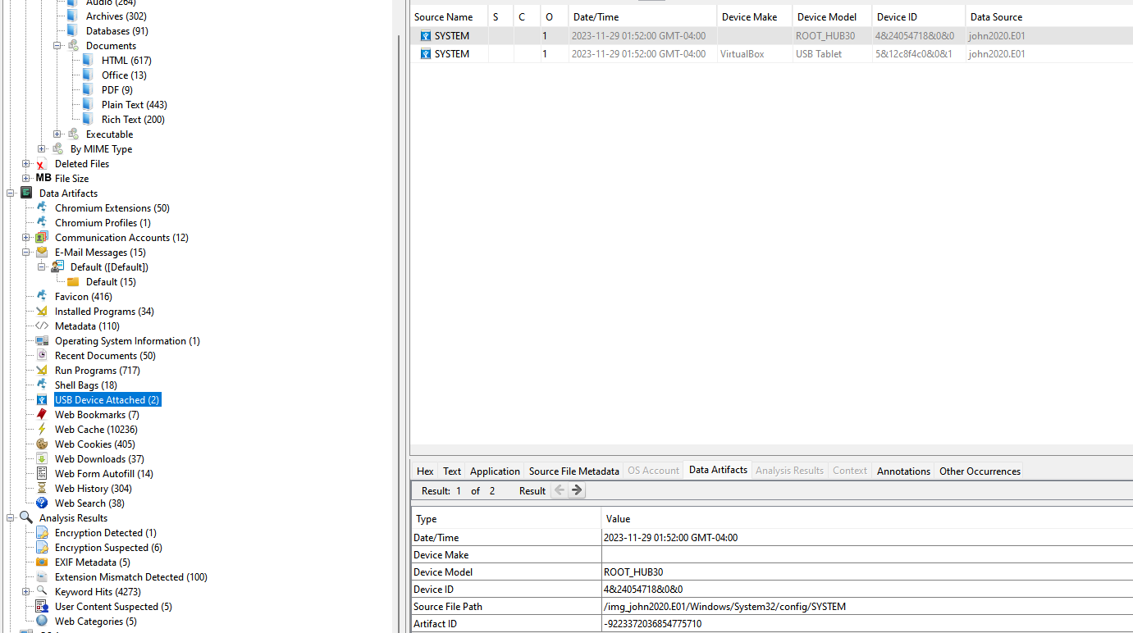

***Fig 23: USB Device Attached***

1. Is there anything noteworthy in his browsing history or saved bookmarks that suggests a connection to the murder?

Upon reviewing web bookmarks, it was discovered that there is a website for buying used cars, potentially indicating the source of escape vehicle from the crime scene. Additionally, bookmarks for "10 ways to cover up murder" and "What is the use and what kind of drug is anesthesia" were identified. Furthermore, in the web history, links to the purchase of tools were found, and the link directed to the Amazon website.

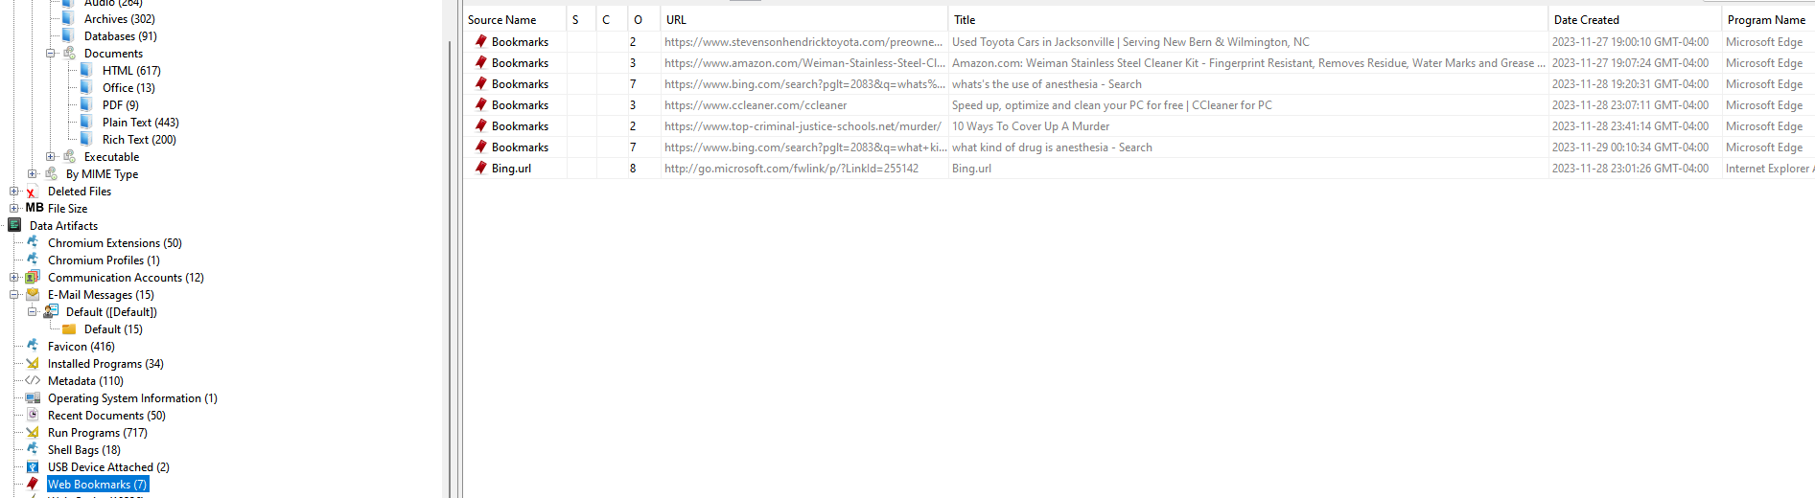

***Fig 24: Bookmarks***

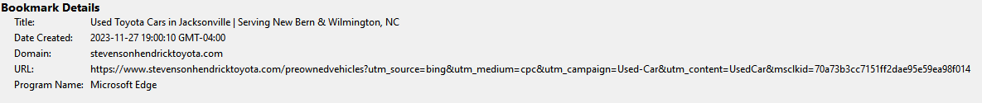

***Fig 25: Second hand car website link***

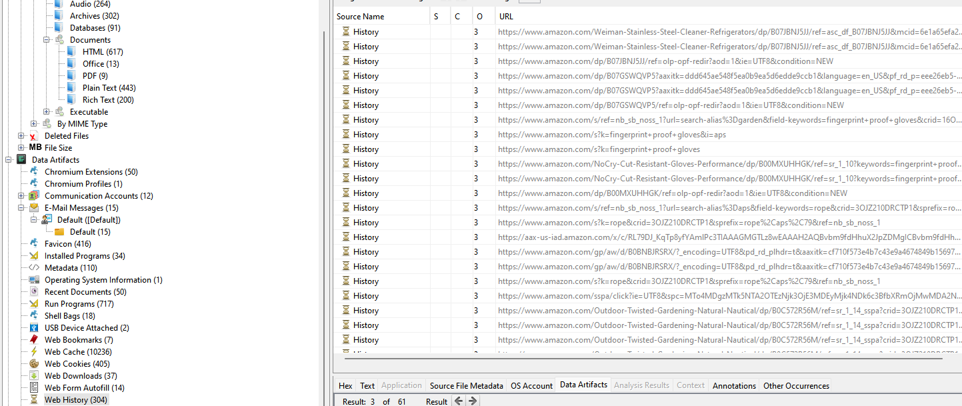

***Fig 26: Web history indicating purchase of tools***

1. Besides the PDF files, is there any other content on John's machine associated with drugs or chemicals that he may require?

In the examination of File types >> By Extension >> Documents >> Plain Text, a file titled "Reminder.txt" was discovered containing a note inquiring about the location where he could acquire nitrous oxide.

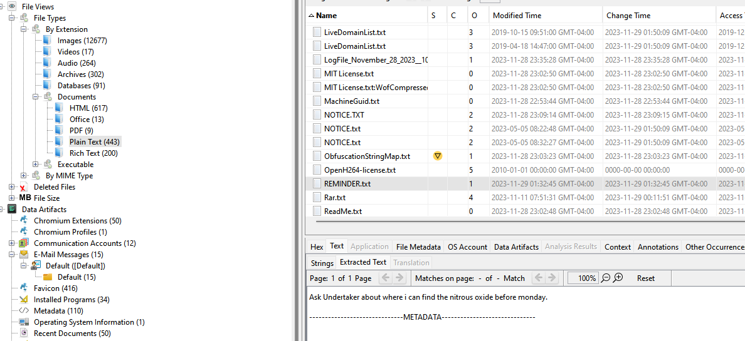

***Fig 27: Reminder.txt***

1. Which operating system is currently running on John's machine, and are there any specific configurations or software that might be relevant to the investigation?

In the examination of Data Artifacts >> Operating System Information, it was revealed that machine was utilizing the Windows 10 Home operating system. To confirm this, I extracted the SOFTWARE file from WINDOWS >> SYSTEM32 >> CONFIG >> SOFTWARE and analyzed it using Access Data Registry Viewer. Within the registry viewer, upon navigating to windows NT >> currentversion, a file named ProductName was identified, providing confirmation that the Windows 10 Home operating system was installed on machine.

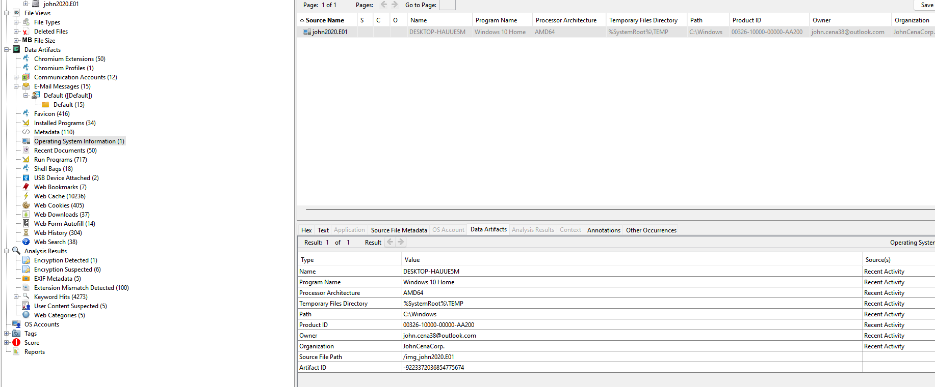

***Fig 28: Operating system information***

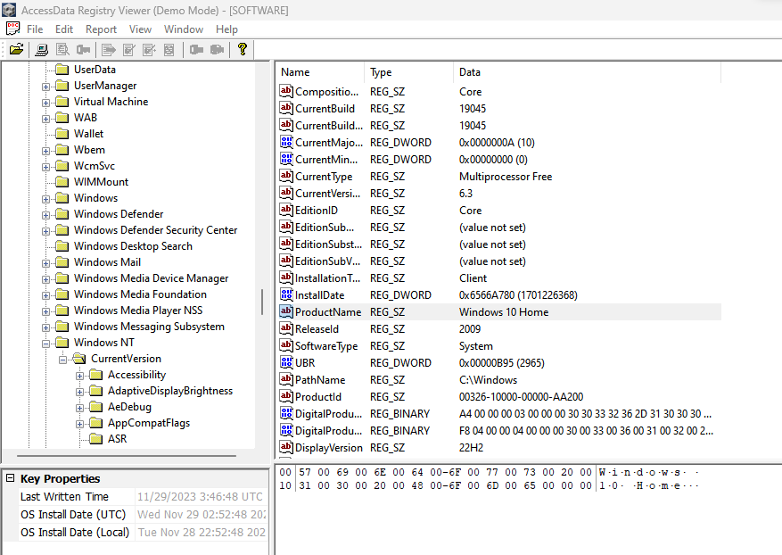

***Fig 29: Confirmation of OS through analyzing Software file***

1. Is there any additional item or tool that John may have utilized prior to causing harm to the Rock?

In the Analysis results >> EXIF metadata, an image referencing Nitrous oxide was identified. Furthermore, in the Web cache, web search, and bookmarks, multiple queries regarding the use of anesthesia and nitrous oxide were uncovered. This strongly suggests the possibility that suspect might utilized nitrous oxide for anesthesia on Rock.

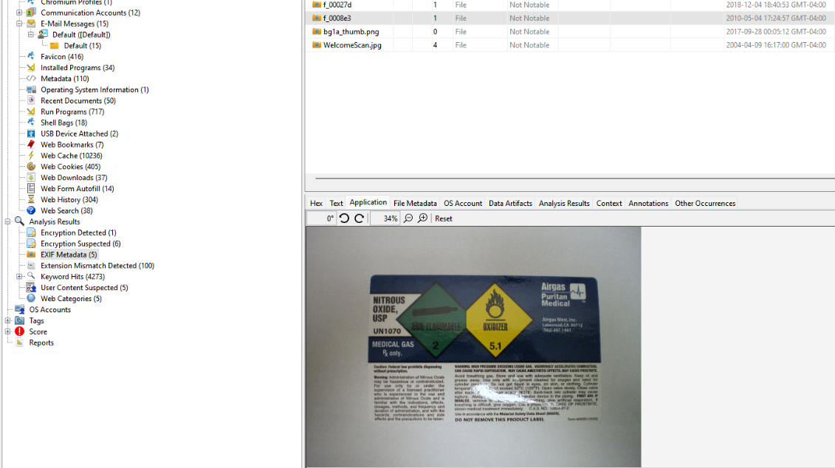

***Fig 30: Nitrous Oxide image in EXIF Metadata***

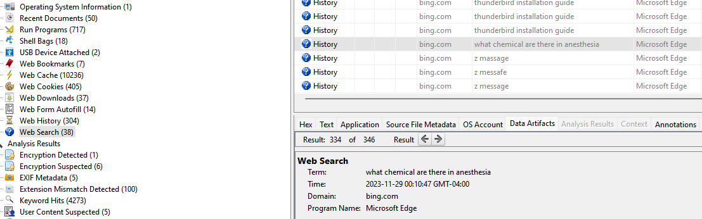

***Fig 31: Web search***

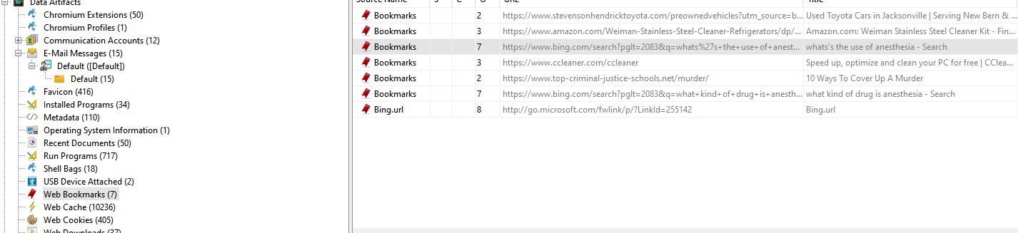

***Fig 32: Web Bookmarks***

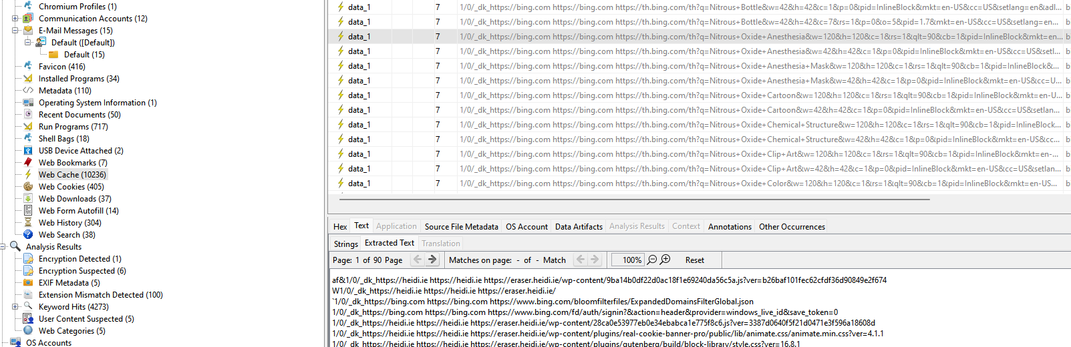

***Fig 33: Web cache***

1. Where do you suspect he acquired the drugs, especially considering his mention of a counterfeit prescription? Can efforts be made to locate the fake prescription?

In his email correspondence, [john.cena38@outlook.com](mailto:john.cena38@outlook.com) sought information from under.taker78@outlook.com on where to obtain Nitrous Oxide. Undertaker.taker78@outlook.com responded by sharing the location of a pharmacy named "Apotheco Pharmacy Charlotte," suggesting it as a potential source for Nitrous Oxide purchase. Furthermore, the email conversation included discussion about a fake prescription. This document, identified as "prescription.pdf," was discovered during the examination of File types >> By Extension >> Documents >> PDF category.

Google maps link of the pharmacy:

<https://www.google.com/maps/place/Apotheco+Pharmacy+Charlotte/@35.2352506,-80.7393129,17z/data=!3m1!5s0x88541f39aa9a32a7:0x7edf0a3a93438d85!4m10!1m2!2m1!1schemical+drug+store+charlotte!3m6!1s0x88541f7f67926833:0x44b5664a8e815565!8m2!3d35.2352506!4d-80.7348068!15sCh1jaGVtaWNhbCBkcnVnIHN0b3JlIGNoYXJsb3R0ZVofIh1jaGVtaWNhbCBkcnVnIHN0b3JlIGNoYXJsb3R0ZZIBCHBoYXJtYWN54AEA!16s%2Fg%2F11qg9d5k8j?entry=ttu>

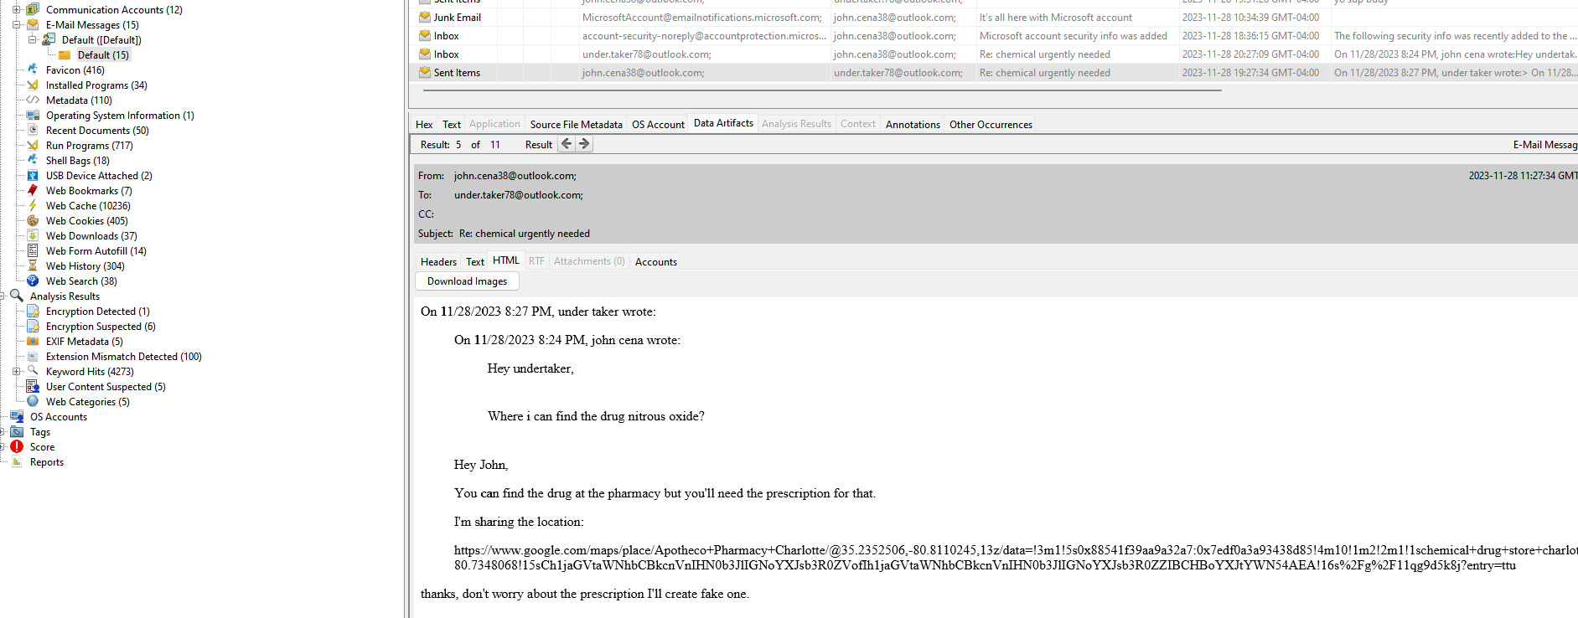

***Fig 34: Mail with location of Pharmacy***

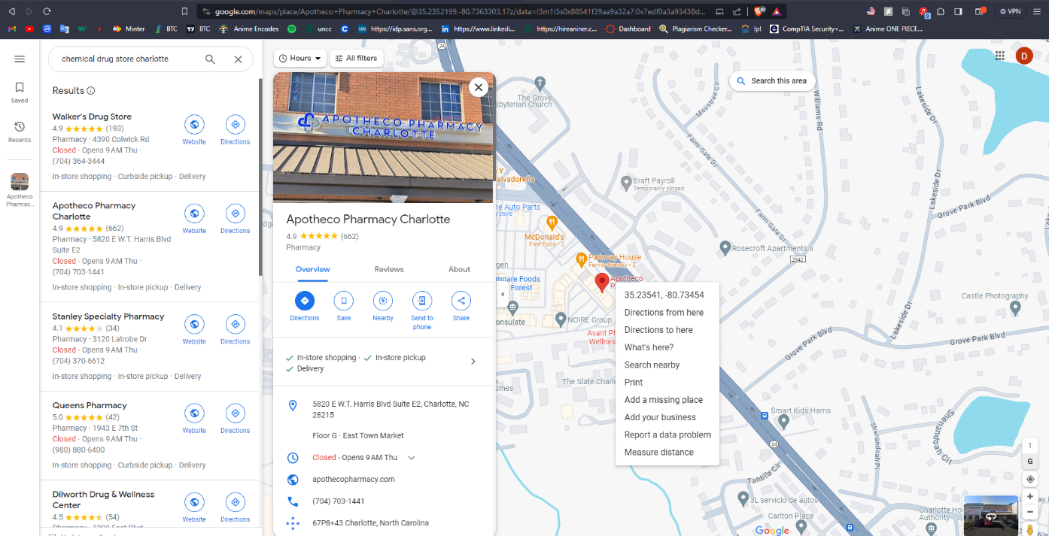

***Fig 35: Location of Pharmacy with coordinates***

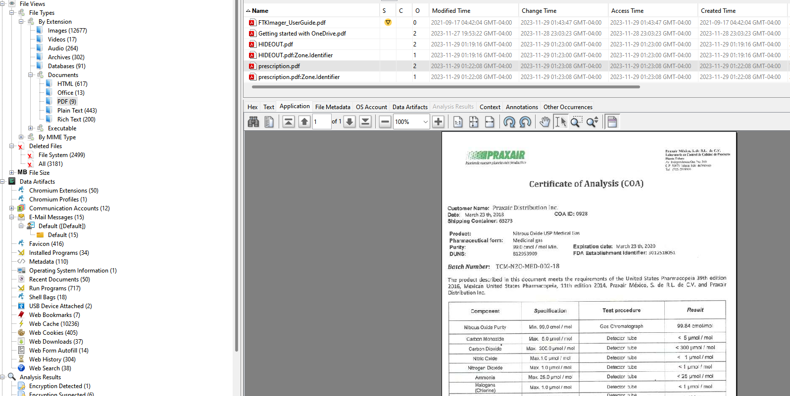

***Fig 36: Prescription.pdf***

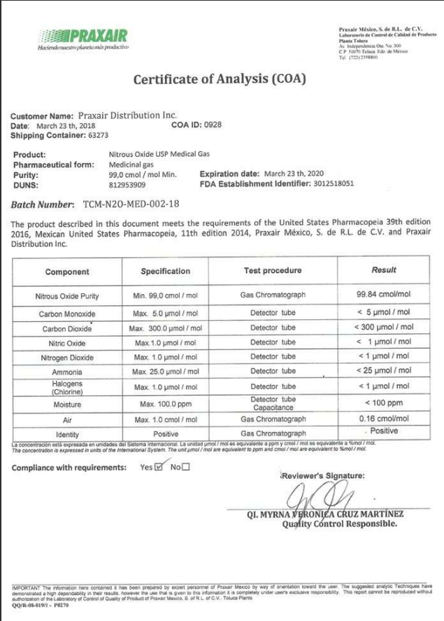

***Fig 37: Fake Prescription***

**Conclusion:**

After scrutinizing the image retrieved from suspect’s computer, as instructed by Detective Rey Mysterio, a thorough examination unveiled several crucial details. The investigation yielded information on the owner of the machine, a potential substance linked to the murder, insights into the likely getaway vehicle used, the origin of the car's purchase, and various images depicting owner of machine and the implements involved. Furthermore, the inquiry exposed the presence of a stolen diamond ring, signs of anti-forensic tools embedded in the system, and the existence of a USB stick.

Noteworthy findings also included the revelation that the operator of the machine had bookmarked the website detailing the chemical used and methods to eradicate murder traces. Additionally, a fake prescription and the location of the corresponding pharmacy were identified. The comprehensive final report, along with the accompanying image files, has been submitted to Detective Rey Mysterio.

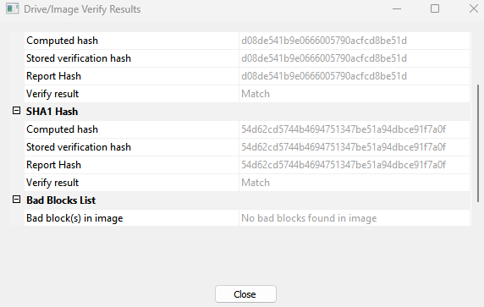

***Fig 38: Re-verifying hash of the image file***

**Author:**

Divyansh Jain